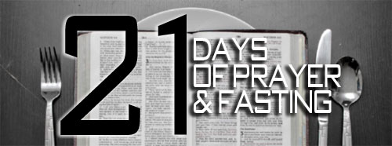

January 12th – February 1st Daily from 6am – 6pm

FASTING

The goal of fasting is to draw nearer to God. Biblical fasting always has to do with eliminating distractions for a spiritual purpose; it hits the reset button of our soul and renews us from the inside out. It also enables us to celebrate the goodness and mercy of God and prepares our hearts for all the good things God desires to bring into our lives. Remember, your personal fast should present a level of challenge, but it is very important to know your body, your options, and, most importantly, to seek God in prayer and follow what the Holy Spirit leads you to do. God desires to bring into our lives.
SCRIPTURE Matthew 6:16-18, Matthew 9:14-15, Luke 18:9-14, Acts 27:33-37, and Nehemiah 9:1-3

Types of Fasts
Your personal fast should present a level of challenge, but it is very important to know your body, your options, and most importantly, to seek God in prayer and follow what the Holy Spirit leads you to do.
Complete Fast
In this type of fast, you drink only liquids, typically water with light juices as an option.
Selective Fast
This type of fast involves removing certain elements from your diet. One example of a selective fast is the Daniel Fast, during which you remove meat, sweets, and bread from your diet and consume water and juice for fluids and fruits and vegetables for food.
Soul Fast
This fast is a great option if you do not have much experience fasting food, have health issues that prevent you from fasting food, or if you wish to refocus certain areas of your life that are out of balance. For example, you might choose to stop using social media or watching television for the duration of the fast and then carefully bring that element back into your life in healthy doses at the conclusion of the fast.

My 21 Day Commitment to Fasting & Prayer
I ______________________________________ (insert name), commit to 21 Days of Fasting & Prayer with my Liberty Outreach Center Church Family.
On this day January ____, I commit to begin on January 12th through February 1st, a full 21 days to this type of Fasting ____________________________.
(Insert Selected Type of Fast)

Beginning January 12th, I commit to Fast From: ____________________________________________________________________________________________________________________________________
(List What You Will Be Specifically Fasting From)

After my 21st day, my Declaration of Faithfulness to God will be: (Daniel 1:8-17)
__________________________________________________________________

Instead of doing the above, I commit to dedicate my time to God, to thoughtful prayer and meditation. I commit to read my word (bible); I commit to spend alone time with God and to do my best to journal daily or weekly my progress between God and Myself.
I Begin Today asking God for help to complete My 21 Day Commitment and I Solicit this Prayer for the Process:
Dear Lord,
________________________________________________________________________________________________________________________________________________________________________________________________________________________________________________________________________________________________________________________________________________________________________________________________________________________________________________________________________________________________________________________________________________
Sincerely; ______________________________________ Dated: _____________

